A
Project Report
Submitted in partial fulfilment of the requirements for the completion of the Course
EDS Lab Codetantra
Practical No.5
(2304102L)

Submitted by,
Pranjal Panmand (202501090112)

Under the Guidance of,

Ms. Madhvi Nimkar(MN)


Department of Mechanical Engineering,
MIT Academy of Engineering,
Alandi road, Pune - 412 105,
Maharashtra (India)

5.1.1. Stacked Plot
20:50
Create a stacked area plot to visualize the temperature variations for three different cities (City A, City B, and City C) across the months of the year. The temperature data is provided for each city in the editor.
Your task is to:
Create a stacked area plot using the data.

Label the x-axis as "Month", the y-axis as "Temperature", and provide the title "Temperature Variation" for the plot.

Display the plot showing the temperature variation for each city throughout the months of the year. import matplotlib.pyplot as plt import pandas as pd
# Data for Months and Temperature for three cities data = {
'Month': ['January', 'February', 'March', 'April', 'May', 'June', 'July', 'August',
'September', 'October', 'November', 'December'],
'City_A_Temperature': [5, 7, 10, 13, 17, 20, 22, 21, 18, 12, 8, 6],
'City_B_Temperature': [2, 3, 5, 6, 10, 14, 16, 17, 12, 9, 5, 3],
'City_C_Temperature ': [3, 4, 6, 8, 9, 12, 15, 14, 10, 7, 4, 2] }
# Write your code
df = pd.DataFrame(data)
plt.stackplot(df['Month'],d f['City_A_Temperature'],df['City_ B _ T emperature'],df['City_C_T emperature']) plt.xlabel('Month') plt.ylabel('Temperature') plt.title('Temperature Variation') plt.show()
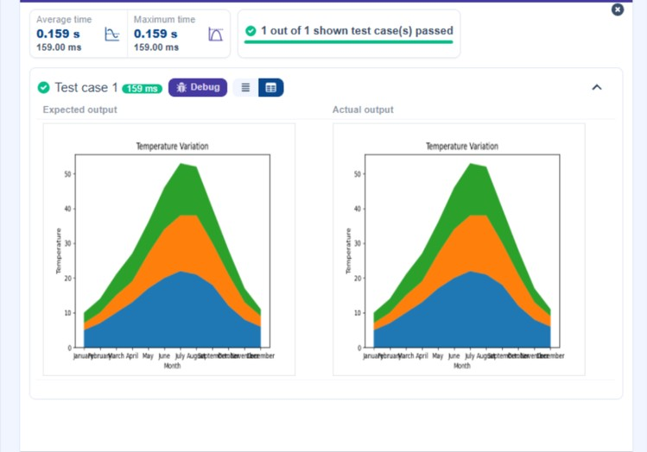
5.2.1. Titanic Dataset
16:35
Write a Python program to analyze and visualize data from the Titanic dataset based on the following instructions:
Dataset Information:
The dataset is stored in a CSV file named titanic.csv and has been loaded using the pandas library. It contains the following columns:
Pclass: Passenger class (1 = First, 2 = Second, 3 = Third).
Gender: Gender of the passenger (male/female).
Age: Age of the passenger.
Survived: Survival status (0 = Did not survive, 1 = Survived).
Fare: Ticket fare paid by the passenger.
Visualization:
To represent these trends, you will create 5 visualizations using Matplotlib. The visualizations should be arranged in a 3x2 grid (3 rows and 2 columns).
Visualization Details:
Write the code to create a series of visualizations as follows:
Bar Plot ( Pclass Distribution) :
Create a bar plot to show the distribution of passengers across the different passenger classes (Pclass).
Use the color skyblue for the bars.
Title the plot as "Passenger Class Distribution" .
Label the x-axis as "Pclass "and the y-axis as "Count" .
Pie Chart (Gender Distribution) :
Create a pie chart to display the distribution of male and female passengers.
Use lightblue for males and lightcoral for females.
Include percentages on the slices (use autopct='%1.1f%%').
Title the plot as "Gender Distribution" .
Histogram (Age Distribution) :
Create a histogram to visualize the distribution of passengers' ages.
Use lightgreen for the bars with black edges ( edgecolor = 'black').
Set the number of bins to 8 for the histogram.
Title the plot as "Age Distribution".
Label the x-axis as "Age" and the y-axis as "Frequency" .
Bar Plot (Survival Count) :
Create a bar plot to show the count of passengers who survived and those who did not, based on the Survived column.
Use the colors lightblue for survivors (1) and lightcoral for non-survivors (0).
Title the plot as "Survival Count" .
Label the x-axis as "Survived (0 =No, 1 =Yes)" and the y-axis as "Count" .
Scatter Plot (Fare vs Age) :
Create a scatter plot to visualize the relationship between the Fare and Age of passengers.
Use orange for the data points.
Title the plot as "Fare vs Age" .
Label the x-axis as "Age" and the y-axis as "Fare" .
N o t e : Refer to the displayed plot in the sample test cases for better understanding.
import pandas as pd
import matplotlib.pyplot as plt
# Load the Titanic dataset from the CSV file df = pd.read_csv('titanic.csv')
# Set up the figure for 5 subplots fig, axes = plt.subplots(3, 2, figsize=(12, 12)) # write the code..
axes[0,0].bar(df['Pclass'].value_counts().index,df['Pclass'].value_count s(),color='skyblue
')
axes[0,0].set_title('Passenger Class Distribution') axes[0,0].set_xlabel('Pclass') axes[0,0].set_ylabel('Count')
gender_counts=df['Gender'].value_counts()
axes[0,1].pie(gender_ counts,labels=gender_counts.index ,colors=['lightblue','lightcoral']) axes[0,1].set_title('Gender Distribution')
axes[1,0].hist(df['Age'].dropna( ),bins=8,color='lightgreen',edgecolor='black') axes[1,0].set_title('Age Distribution') axes[1,0].set_xlabel('Age') axes[1,0].set_ylabel('Frequency') survival_counts=df['Survived'].value_counts()
axes[1,1].bar(survival_counts.index,survival_counts,color=['lightblue','lightcoral']) axes[1,1].set_title('Survival Count') axes[1,1].set_xlabel('Survived (0 = No, 1 = Yes)') axes[1,1].set_ylabel('Count')
axes[2,0].scatter(df['Age'],df['Fare'],color='ora n g e ') axes[2,0].set_title('Fare vs Age') axes[2,0].set_xlabel('Age') axes[2,0].set_ylabel('Fare') axes[2,1].plot ()
axes[2,1].set_xlim(0,1) axes[2,1].set_ylim(0,1) plt.tight_layout() plt.show()
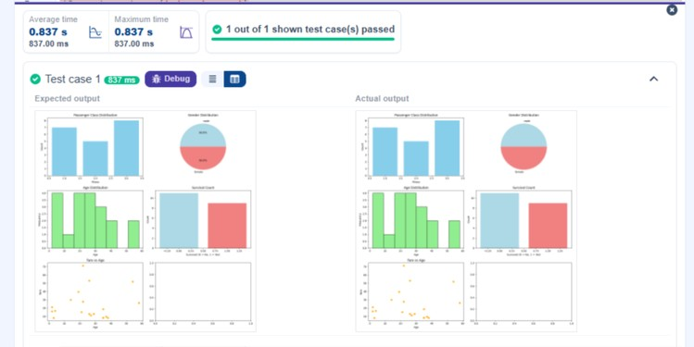
5.2.2. Histogram of passenger information of Titanic
01:19
Write a Python code to plot a histogram for the distribution of the 'Age' column from the Titanic dataset. The histogram should display the frequency of different age ranges with the following specifications:
- Use 3 0 bins for the histogram.
- Set the edge color of the bars to b l a c k (k).
- Label the x-axis as 'Age' and the y-axis as 'Frequency' .
- Add the title "Age Distribution" to the histogram.
PassengerId | Survived | Pclass | Name | Sex | Age | SibSp | Parch | Ticket
The Titanic dataset contains columns as shown below,
Sample Data:
PassengerId,Survived ,Pclass,Name ,Sex,Age,SibSp,Parch,Ti c k e t,Fare,Cabin,Embarked
1,0,3,"Braund, Mr. Owen Harris",male,22,1,0,A/5 21171,7.25,,S
2,1,1,"Cumings, Mrs. John Bradley (Florence Briggs Thayer)",female,38,1, 0,PC
17599,71.2833,C85,C
3,1,3,"Heikkinen, Miss. Laina",female,26, 0,0,STON/O2. 3101282,7.925,,S
4,1,1,"Futrelle, Mrs. Jacques Heath (Lily May Peel)",female,35,1,0,113803,53. 1,C1 2 3 ,S
5,0,3,"Allen, Mr. William Henry",male,35,0,0,3 7 3 4 5 0 ,8.05,,S
6,0,3,"Moran, Mr. James ",male,,0,0,330877,8.4583,,Q
7,0,1,"McCarthy, Mr. Timothy J",male,54,0,0,17463, 51.8625,E46,S
8,0,3,"Palsson, Master. Gosta Leonard",male,2,3,1,349909,21.075,,S
9,1,3,"Johnson, Mrs. Oscar W (Elisabeth Vilhelmina
Berg)",female,27,0,2,347742, 11.1333,,S
10,1,2,"Nasser, Mrs. Nicholas (Adele Achem)",female,14,1,0, 237736,30.0708,,C Note: Refer to the visible test case for better reference.
import pandas as pd
import matplotlib.pyplot as plt
# Load the Titanic dataset data = pd.read_csv('Titanic-Dataset.csv')
# Data Cleaning
data['Age'].fillna(data['Age'].median (), inplace=True) data['Embarked'].fillna(data['Embarked'].mode()[0], inplace=True) data.drop('Cabin', axis=1, inplace=True)
# Convert categorical features to numeric data['Sex'] = data['Sex'].map({'male': 0, 'female': 1})
data = pd.get_dummies(data, columns=['Embarked'], drop_first =True)
# Write your code here for Histogram plt.hist(data['Age'], bins=30, edgecolor='k')
plt.xlabel('Age') plt.ylabel('Frequency') plt.title('Age Distribution') plt.show()
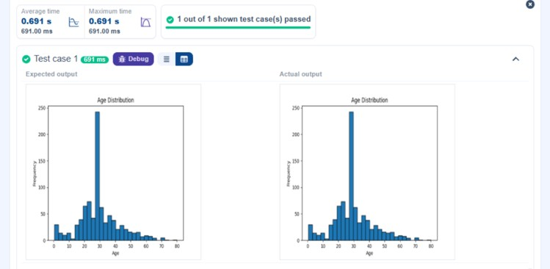
5.2.3. Bar plot of survival rate of passengers
15:39
Write a Python code to plot a bar chart that shows the count of passengers who survived and did not survive in the Titanic dataset. The chart should display the following specifications:
- Use the 'Survived ' column to show the count of survivors (0 = Did not survive, 1 = Survived).
- Set the chart type to 'bar '.
- Add the title "Survival Count " to the chart.
- Label the x-axis as 'Survived ' and the y-axis as 'Count '.
PassengerId | Survived | Pclass | Name | Sex | Age | SibSp | Parch | Ticket
The Titanic dataset contains columns as shown below,
Sample Data:
PassengerId,Survived ,Pclass,Name ,Sex,Age,SibSp,Parch,Ti c k e t,Fare,Cabin,Embarked
1,0,3,"Braund, Mr. Owen Harris",male,22,1,0,A/5 21171,7.25,,S
2,1,1,"Cumings, Mrs. John Bradley (Florence Briggs Thayer)",female,38,1, 0,PC
17599,71.2833,C85,C
3,1,3,"Heikkinen, Miss. Laina",female,26, 0,0,STON/O2. 3101282,7.925,,S
4,1,1,"Futrelle, Mrs. Jacques Heath (Lily May Peel)",female,35,1,0,113803,53. 1,C1 2 3 ,S
5,0,3,"Allen, Mr. William Henry",male,35,0,0,3 7 3 4 5 0 ,8.05,,S
6,0,3,"Moran, Mr. James ",male,,0,0,330877,8.4583,,Q
7,0,1,"McCarthy, Mr. Timothy J",male,54,0,0,17463, 51.8625,E46,S
8,0,3,"Palsson, Master. Gosta Leonard",male,2,3,1,349909,21.075,,S
9,1,3,"Johnson, Mrs. Oscar W (Elisabeth Vilhelmina
Berg)",female,27,0,2,347742, 11.1333,,S
10,1,2,"Nasser, Mrs. Nicholas (Adele Achem)",female,14,1,0, 237736,30.0708,,C Note: Refer to the visible test case for better reference.
import pandas as pd
import matplotlib.pyplot as plt
# Load the Titanic dataset data = pd.read_csv('Titanic-Dataset.csv')
# Data Cleaning
data['Age'].fillna(data['Age'].median (), inplace=True) data['Embarked'].fillna(data['Embarked'].mode()[0], inplace=True) data.drop('Cabin', axis=1, inplace=True)
# Convert categorical features to numeric data['Sex'] = data['Sex'].map({'male': 0, 'female': 1})
data = pd.get_dummies(data, columns=['Embarked'], drop_first =True)
# Write your code here for Bar Plot for Survival Rate survival_counts=data['Survived'].value_counts().sort_index () plt.figure()
survival_counts.plot(kind='bar') plt.title('Survival Count') plt.xlabel('Survived') plt.ylabel('Count') plt.show()

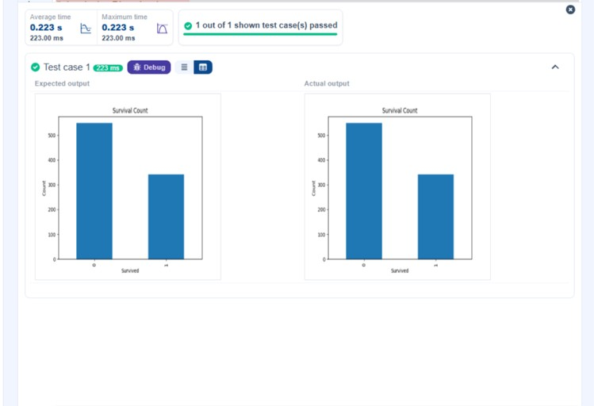

5.2.4. Bar Plot for Survival by Gender
01:21
Write a Python code to plot a stacked bar chart that shows the count of passengers who survived and did not survive, grouped by gender, in the Titanic dataset. The chart should display the following specifications:
- Group the data by the 'Sex' column, then use the value_ counts ( ) function to count the occurrences of survivors (0 = Did not survive, 1 = Survived) for each gender.
- Use a stacked bar chart to display the survival counts.
- Add the title "Survival by Gender" to the chart.
- Label the x-axis as 'Gender' and the y-axis as 'Count' .
- The legend should indicate 'Not Survived' and 'Survived' .
PassengerId | Survived | Pclass | Name | Sex | Age | SibSp | Parch | Ticket
The Titanic dataset contains columns as shown below,
Sample Data:
PassengerId,Survived ,Pclass,Name ,Sex,Age,SibSp,Parch,Ti c k e t,Fare,Cabin,Embarked
1,0,3,"Braund, Mr. Owen Harris",male,22,1,0,A/5 21171,7.25,,S
2,1,1,"Cumings, Mrs. John Bradley (Florence Briggs Thayer)",female,38,1, 0,PC
17599,71.2833,C85,C
3,1,3,"Heikkinen, Miss. Laina",female,26, 0,0,STON/O2. 3101282,7.925,,S
4,1,1,"Futrelle, Mrs. Jacques Heath (Lily May Peel)",female,35,1,0,113803,53. 1,C1 2 3 ,S
5,0,3,"Allen, Mr. William Henry",male,35,0,0,3 7 3 4 5 0 ,8.05,,S
6,0,3,"Moran, Mr. James ",male,,0,0,330877,8.4583,,Q
7,0,1,"McCarthy, Mr. Timothy J",male,54,0,0,17463, 51.8625,E46,S
8,0,3,"Palsson, Master. Gosta Leonard",male,2,3,1,349909,21.075,,S
9,1,3,"Johnson, Mrs. Oscar W (Elisabeth Vilhelmina
Berg)",female,27,0,2,347742, 11.1333,,S
10,1,2,"Nasser, Mrs. Nicholas (Adele Achem)",female,14,1,0, 237736,30.0708,,C
Note: Refer to the visible test case for better reference.
import pandas as pd import matplotlib.pyplot as plt
# Load the Titanic dataset data = pd.read_csv('Titanic-Dataset.csv')
# Data Cleaning
data['Age'].fillna(data['Age'].median (), inplace=True) data['Embarked'].fillna(data['Embarked'].mode()[0], inplace=True) data.drop('Cabin', axis=1, inplace=True)
# Convert categorical features to numeric data['Sex'] = data['Sex'].map({'male': 0, 'female': 1})
data = pd.get_dummies(data, columns=['Embarked'], drop_first =True)
# Write your code here for Bar Plot for Survival by Gender counts = data.groupby('Sex')['Survived'].value_counts().unstack ()
counts.plot(kind='bar', stacked=True)
plt.title("Survival by Gender") plt.xlabel("Gender") plt.ylabel("Count")
plt.legend(["Not Survived", "Survived"])
plt.show()
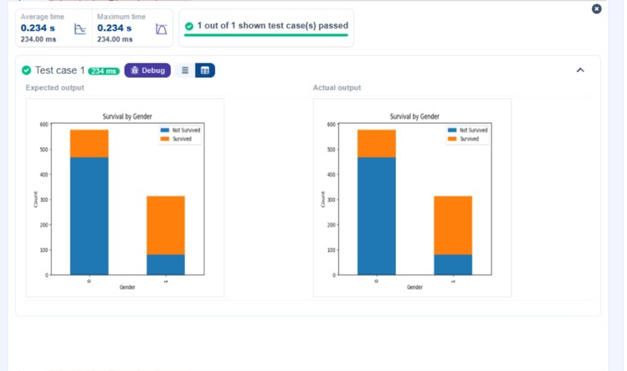
5.2.5. Bar Plot for Survival by Pclass
01:17
Write a Python code to plot a stacked bar chart that shows the count of passengers who survived and did not survive, grouped by passenger class (Pclass ), in the Titanic dataset. The chart should display the following specifications:
- Group the data by the Pclass column and count the number of survivors (0 = Did not survive, 1 = Survived) for each class using value_ counts ( ) .
- Use a stacked bar chart to display the survival counts.
- Add the title "Survival by Pclass " to the chart.
- Label the x-axis as 'Pclass ' and the y-axis as 'Count' .
- The legend should indicate 'Not Survived' and 'Survived' .
PassengerId | Survived | Pclass | Name | Sex | Age | SibSp | Parch
The Titanic dataset contains columns as shown below,
Sample Data:
PassengerId,Survived ,Pclass,Name ,Sex,Age,SibSp,Parch,Ti c k e t,Fare,Cabin,Embarked
1,0,3,"Braund, Mr. Owen Harris",male,22,1,0,A/5 21171,7.25,,S
2,1,1,"Cumings, Mrs. John Bradley (Florence Briggs Thayer)",female,38,1, 0,PC
17599,71.2833,C85,C
3,1,3,"Heikkinen, Miss. Laina",female,26, 0,0,STON/O2. 3101282,7.925,,S
4,1,1,"Futrelle, Mrs. Jacques Heath (Lily May Peel)",female,35,1,0,113803,53. 1,C1 2 3 ,S
5,0,3,"Allen, Mr. William Henry",male,35,0,0,3 7 3 4 5 0 ,8.05,,S
6,0,3,"Moran, Mr. James ",male,,0,0,330877,8.4583,,Q
7,0,1,"McCarthy, Mr. Timothy J",male,54,0,0,17463, 51.8625,E46,S
8,0,3,"Palsson, Master. Gosta Leonard",male,2,3,1,349909,21.075,,S
9,1,3,"Johnson, Mrs. Oscar W (Elisabeth Vilhelmina
Berg)",female,27,0,2,347742, 11.1333,,S
10,1,2,"Nasser, Mrs. Nicholas (Adele Achem)",female,14,1,0, 237736,30.0708,,C
Note:
Refer to the visible test case for better reference.
Ensure you use the groupby ( ) function with value_ counts ( ) to count the survivors and non-survivors for each Pclass .
Do not manually use size( ) or unstack( ) without value_ counts ( ) . Use the value_ counts ( ) method for counting survival status directly.
import pandas as pd import matplotlib.pyplot as plt
# Load the Titanic dataset data = pd.read_csv('Titanic-Dataset.csv')
# Data Cleaning
data['Age'].fillna(data['Age'].median (), inplace=True) data['Embarked'].fillna(data['Embarked'].mode()[0], inplace=True) data.drop('Cabin', axis=1, inplace=True)
# Convert categorical features to numeric data['Sex'] = data['Sex'].map({'male': 0, 'female': 1})
data = pd.get_dummies(data, columns=['Embarked'], drop_first =True)
# Write your code here for Bar Plot for Survival by Pclass counts = data.groupby('Pclass')['Survived'].va l u e _counts().unstack()
counts.plot(kind='bar', stacked=True)
plt.title("Survival by Pclass") plt.xlabel("Pclass") plt.ylabel("Count")
plt.legend(["Not Survived", "Survived"])
plt.show()
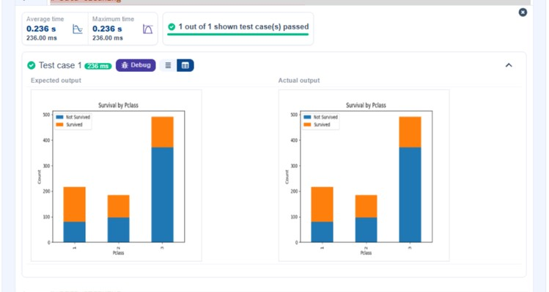
5.2.6. Bar Plot for Survival by Embarked
04:55
Write a Python code to plot a stacked bar chart showing the survival count for passengers based on their embarkation location in the Titanic dataset.
The chart should display the following specifications:
- Use the Embarked column to determine the embarkation location. After converting this column into dummy variables (using pd.get_ dummies ( ) ), plot the survival count based on the Emba rke d_Q column (representing passengers who embarked from Queenstown) in relation to survival.
- Set the chart type to 'bar' and make it stacked.
- Add the title "Survival by Embarked " to the chart.
- Label the x-axis as 'Embarked' and the y-axis as 'Count' .
PassengerId | Survived | Pclass | Name | Sex | Age | SibSp | Parch
- Include a legend to distinguish between survivors and non-survivors (label the legend as 'Survived' and 'Not Survived' ). The Titanic dataset contains columns as shown below,
Sample Data:
PassengerId,Survived ,Pclass,Name ,Sex,Age,SibSp,Parch,Ti c k e t,Fare,Cabin,Embarked
1,0,3,"Braund, Mr. Owen Harris",male,22,1,0,A/5 21171,7.25,,S
2,1,1,"Cumings, Mrs. John Bradley (Florence Briggs Thayer)",female,38,1, 0,PC
17599,71.2833,C85,C
3,1,3,"Heikkinen, Miss. Laina",female,26, 0,0,STON/O2. 3101282,7.925,,S
4,1,1,"Futrelle, Mrs. Jacques Heath (Lily May Peel)",female,35,1,0,113803,53. 1,C1 2 3 ,S
5,0,3,"Allen, Mr. William Henry",male,35,0,0,3 7 3 4 5 0 ,8.05,,S
6,0,3,"Moran, Mr. James ",male,,0,0,330877,8.4583,,Q
7,0,1,"McCarthy, Mr. Timothy J",male,54,0,0,17463, 51.8625,E46,S
8,0,3,"Palsson, Master. Gosta Leonard",male,2,3,1,349909,21.075,,S
9,1,3,"Johnson, Mrs. Oscar W (Elisabeth Vilhelmina
Berg)",female,27,0,2,347742, 11.1333,,S
10,1,2,"Nasser, Mrs. Nicholas (Adele Achem)",female,14,1,0, 237736,30.0708,,C
Note: Refer to the visible test case for better reference.
import pandas as pd import matplotlib.pyplot as plt
# Load the Titanic dataset data = pd.read_csv('Titanic-Dataset.csv')
# Data Cleaning
data['Age'].fillna(data['Age'].median (), inplace=True) data['Embarked'].fillna(data['Embarked'].mode()[0], inplace=True) data.drop('Cabin', axis=1, inplace=True)
# Convert categorical features to numeric data['Sex'] = data['Sex'].map({'male': 0, 'female': 1})
data = pd.get_dummies(data, columns=['Embarked'], drop_first =True)
# Write your code here for Bar Plot for Survival by Embarked grouped = pd.crosstab(data['Embarked_Q'],dat a['Survived']) grouped.plot(kind=' bar',stacked=True) plt.xlabel('Embarked') plt.ylabel('Count') plt.title('Survival by Embarked') plt.legend(['Not Survived','Survived'])
plt.show()
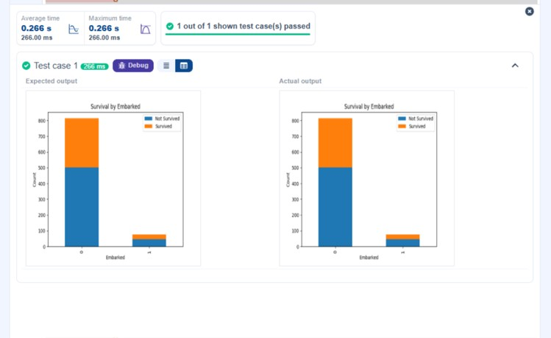
5.2.7. Box plot for Age Distribution
00:56
Write a Python code to plot a boxplot that shows the distribution of the 'Age' column from the Titanic dataset across different passenger classes. The boxplot should display the following specifications:
- Use the Pclass column to group the data for the boxplot.
- Set the title of the plot to "Age by Pclass ".
- Remove the default subtitle with plt.suptitle ('') .
- Label the x-axis as 'Pclass ' and the y-axis as 'Age' .
PassengerId | Survived | Pclass | Name | Sex | Age | SibSp | Parch
The Titanic dataset contains columns as shown below,
Sample Data:
PassengerId,Survived ,Pclass,Name ,Sex,Age,SibSp,Parch,Ti c k e t,Fare,Cabin,Embarked
1,0,3,"Braund, Mr. Owen Harris",male,22,1,0,A/5 21171,7.25,,S
2,1,1,"Cumings, Mrs. John Bradley (Florence Briggs Thayer)",female,38,1, 0,PC
17599,71.2833,C85,C
3,1,3,"Heikkinen, Miss. Laina",female,26, 0,0,STON/O2. 3101282,7.925,,S
4,1,1,"Futrelle, Mrs. Jacques Heath (Lily May Peel)",female,35,1,0,113803,53. 1,C1 2 3 ,S
5,0,3,"Allen, Mr. William Henry",male,35,0,0,3 7 3 4 5 0 ,8.05,,S
6,0,3,"Moran, Mr. James ",male,,0,0,330877,8.4583,,Q
7,0,1,"McCarthy, Mr. Timothy J",male,54,0,0,17463, 51.8625,E46,S
8,0,3,"Palsson, Master. Gosta Leonard",male,2,3,1,349909,21.075,,S
9,1,3,"Johnson, Mrs. Oscar W (Elisabeth Vilhelmina
Berg)",female,27,0,2,347742, 11.1333,,S
10,1,2,"Nasser, Mrs. Nicholas (Adele Achem)",female,14,1,0, 237736,30.0708,,C Note: Refer to the visible test case for better reference.
import pandas as pd import matplotlib.pyplot as plt # Load the Titanic dataset data = pd.read_csv('Titanic-Dataset.csv')
# Data Cleaning
data['Age'].fillna(data['Age'].median (), inplace=True) data['Embarked'].fillna(data['Embarked'].mode()[0], inplace=True) data.drop('Cabin', axis=1, inplace=True)
# Convert categorical features to numeric data['Sex'] = data['Sex'].map({'male': 0, 'female': 1})
data = pd.get_dummies(data, columns=['Embarked'], drop_first =True)
# Boxplot of Age grouped by Pclass data.boxplot(column='Age', by='Pclass')
# Remove default subtitle plt.suptitle('')
# Set title and axis labels plt.title("Age by Pclass") plt.xlabel("Pclass") plt.ylabel("Age") # Show plot
plt.show()
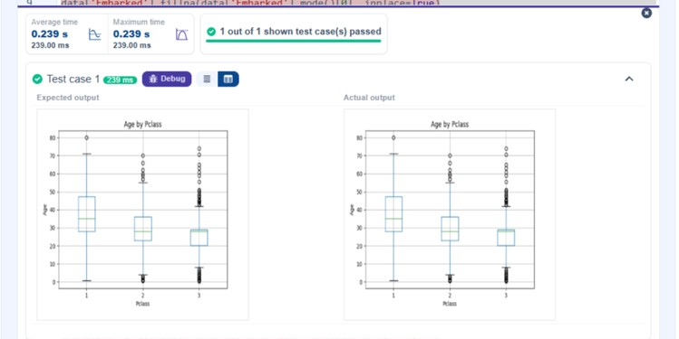
5.2.8. Box Plot for Age by Survived
00:47
Write a Python code to plot a boxplot that shows the distribution of the 'Age' column from the Titanic dataset based on whether passengers survived or not. The boxplot should display the following specifications:
- Use the Survived column to group the data for the boxplot (0 = Did not survive, 1 = Survived).
- Set the title of the plot to "Age by Survival" .
- Remove the default subtitle with plt.suptitle ('') .
- Label the x-axis as 'Survived' and the y-axis as 'Age' .
PassengerId | Survived | Pclass | Name | Sex | Age | SibSp | Parch
The Titanic dataset contains columns as shown below,
Sample Data:
PassengerId,Survived ,Pclass,Name ,Sex,Age,SibSp,Parch,Ti c k e t,Fare,Cabin,Embarked
1,0,3,"Braund, Mr. Owen Harris",male,22,1,0,A/5 21171,7.25,,S
2,1,1,"Cumings, Mrs. John Bradley (Florence Briggs Thayer)",female,38,1, 0,PC
17599,71.2833,C85,C
3,1,3,"Heikkinen, Miss. Laina",female,26, 0,0,STON/O2. 3101282,7.925,,S
4,1,1,"Futrelle, Mrs. Jacques Heath (Lily May Peel)",female,35,1,0,113803,53. 1,C1 2 3 ,S
5,0,3,"Allen, Mr. William Henry",male,35,0,0,3 7 3 4 5 0 ,8.05,,S
6,0,3,"Moran, Mr. James ",male,,0,0,330877,8.4583,,Q
7,0,1,"McCarthy, Mr. Timothy J",male,54,0,0,17463, 51.8625,E46,S
8,0,3,"Palsson, Master. Gosta Leonard",male,2,3,1,349909,21.075,,S
9,1,3,"Johnson, Mrs. Oscar W (Elisabeth Vilhelmina
Berg)",female,27,0,2,347742, 11.1333,,S
10,1,2,"Nasser, Mrs. Nicholas (Adele Achem)",female,14,1,0, 237736,30.0708,,C Note: Refer to the visible test case for better reference.
import pandas as pd import matplotlib.pyplot as plt # Load the Titanic dataset data = pd.read_csv('Titanic-Dataset.csv')
# Data Cleaning
data['Age'].fillna(data['Age'].median (), inplace=True) data['Embarked'].fillna(data['Embarked'].mode()[0], inplace=True) data.drop('Cabin', axis=1, inplace=True)
# Convert categorical features to numeric data['Sex'] = data['Sex'].map({'male': 0, 'female': 1})
data = pd.get_dummies(data, columns=['Embarked'], drop_first =True)
# Boxplot of Age grouped by Survived data.boxplot(column='Age', by='Survived')
# Remove default subtitle plt.suptitle('')
# Set title and axis labels plt.title("Age by Survival") plt.xlabel("Survived") plt.ylabel("Age") # Show plot
plt.show()
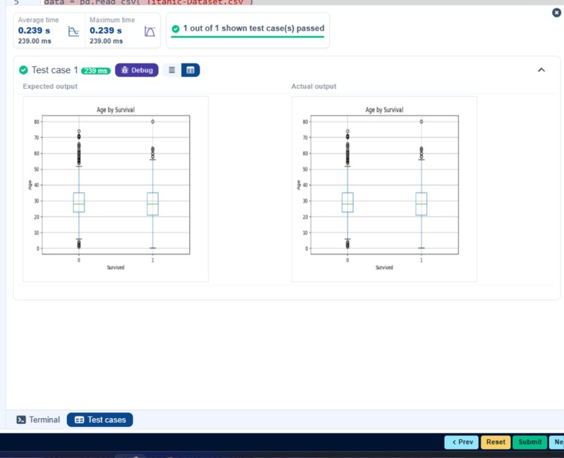
5.2.9. Box Plot for Fare by Pclass
01:13
Write a Python code to plot a boxplot that shows the distribution of the 'Fare' column from the Titanic dataset based on the passenger class (Pclass). The boxplot should display the following specifications:
- Use the Pclass column to group the data for the boxplot.
- Set the title of the plot to "Fare by Pclass ".
- Remove the default subtitle with plt.suptitle ('') .
- Label the x-axis as 'Pclass ' and the y-axis as 'Fare' .
PassengerId | Survived | Pclass | Name | Sex | Age | SibSp | Parch
The Titanic dataset contains columns as shown below,
Sample Data:
PassengerId,Survived ,Pclass,Name ,Sex,Age,SibSp,Parch,Ti c k e t,Fare,Cabin,Embarked
1,0,3,"Braund, Mr. Owen Harris",male,22,1,0,A/5 21171,7.25,,S
2,1,1,"Cumings, Mrs. John Bradley (Florence Briggs Thayer)",female,38,1, 0,PC
17599,71.2833,C85,C
3,1,3,"Heikkinen, Miss. Laina",female,26, 0,0,STON/O2. 3101282,7.925,,S
4,1,1,"Futrelle, Mrs. Jacques Heath (Lily May Peel)",female,35,1,0,113803,53. 1,C1 2 3 ,S
5,0,3,"Allen, Mr. William Henry",male,35,0,0,3 7 3 4 5 0 ,8.05,,S
6,0,3,"Moran, Mr. James ",male,,0,0,330877,8.4583,,Q
7,0,1,"McCarthy, Mr. Timothy J",male,54,0,0,17463, 51.8625,E46,S
8,0,3,"Palsson, Master. Gosta Leonard",male,2,3,1,349909,21.075,,S
9,1,3,"Johnson, Mrs. Oscar W (Elisabeth Vilhelmina
Berg)",female,27,0,2,347742, 11.1333,,S
10,1,2,"Nasser, Mrs. Nicholas (Adele Achem)",female,14,1,0, 237736,30.0708,,C Note: Refer to the visible test case for better reference.
import pandas as pd import matplotlib.pyplot as plt # Load the Titanic dataset data = pd.read_csv('Titanic-Dataset.csv')
# Data Cleaning
data['Age'].fillna(data['Age'].median (), inplace=True) data['Embarked'].fillna(data['Embarked'].mode()[0], inplace=True) data.drop('Cabin', axis=1, inplace=True)
# Convert categorical features to numeric data['Sex'] = data['Sex'].map({'male': 0, 'female': 1})
data = pd.get_dummies(data, columns=['Embarked'], drop_first =True)
# Boxplot of Fare grouped by Pclass data.boxplot(column='Fare', by='Pclass')
# Remove default subtitle plt.suptitle('')
# Set title and axis labels plt.title("Fare by Pclass") plt.xlabel("Pclass") plt.ylabel("Fare") # Show plot
plt.show()
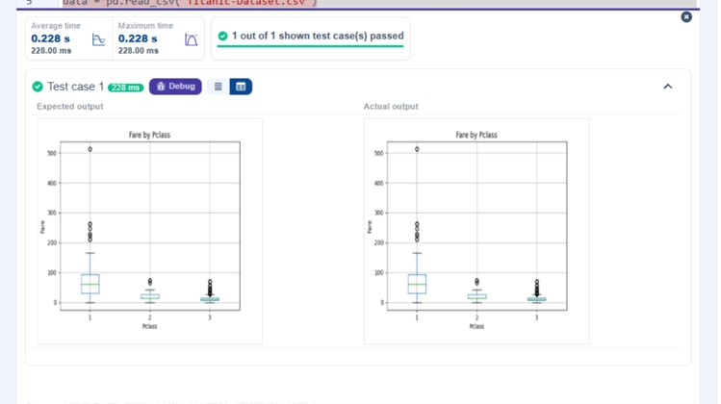
5.2.10. Scatter Plot for Age vs. Fare
05:23
Write a Python code to plot a scatter plot showing the relationship between the 'Age' and 'Fare' columns in the Titanic dataset. The scatter plot should display the following specifications:
- Use the Age column for the x-axis and the Fare column for the y-axis.
- Set the title of the plot to "Age vs. Fare" .
- Label the x-axis as 'Age' and the y-axis as 'Fare' .
PassengerId | Survived | Pclass | Name | Sex | Age | SibSp | Parch
The Titanic dataset contains columns as shown below,
Sample Data:
PassengerId,Survived ,Pclass,Name ,Sex,Age,SibSp,Parch,Ti c k e t,Fare,Cabin,Embarked
1,0,3,"Braund, Mr. Owen Harris",male,22,1,0,A/5 21171,7.25,,S
2,1,1,"Cumings, Mrs. John Bradley (Florence Briggs Thayer)",female,38,1, 0,PC
17599,71.2833,C85,C
3,1,3,"Heikkinen, Miss. Laina",female,26, 0,0,STON/O2. 3101282,7.925,,S
4,1,1,"Futrelle, Mrs. Jacques Heath (Lily May Peel)",female,35,1,0,113803,53. 1,C1 2 3 ,S
5,0,3,"Allen, Mr. William Henry",male,35,0,0,3 7 3 4 5 0 ,8.05,,S
6,0,3,"Moran, Mr. James ",male,,0,0,330877,8.4583,,Q
7,0,1,"McCarthy, Mr. Timothy J",male,54,0,0,17463, 51.8625,E46,S
8,0,3,"Palsson, Master. Gosta Leonard",male,2,3,1,349909,21.075,,S
9,1,3,"Johnson, Mrs. Oscar W (Elisabeth Vilhelmina
Berg)",female,27,0,2,347742, 11.1333,,S
10,1,2,"Nasser, Mrs. Nicholas (Adele Achem)",female,14,1,0, 237736,30.0708,,C
Note: Refer to the visible test case for better reference.
import pandas as pd
import matplotlib.pyplot as plt
# Load the Titanic dataset data = pd.read_csv('Titanic-Dataset.csv')
# Data Cleaning
data['Age'].fillna(data['Age'].median (), inplace=True) data['Embarked'].fillna(data['Embarked'].mode()[0], inplace=True) data.drop('Cabin', axis=1, inplace=True)
# Convert categorical features to numeric data['Sex'] = data['Sex'].map({'male': 0, 'female': 1})
data = pd.get_dummies(data, columns=['Embarked'], drop_first =True)
#Write your code here for Box Plot for Fare by Pclass plt.scatter(data['Age'],data['Fare']) plt.title('Age vs. Fare') plt.xlabel('Age') plt.ylabel('Fare')
plt.show()
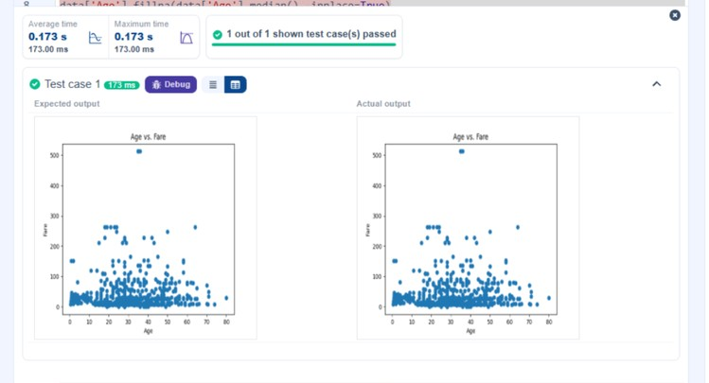
5.2.11. Scatter Plot for Age vs. Fare by Survived
28:21
Write a Python code to plot a scatter plot showing the relationship between the 'Age' and 'Fare' columns in the Titanic dataset, with points color-coded by survival status. The scatter plot should display the following specifications:
- Use the Age column for the x-axis and the Fare column for the y-axis.
- Color the points based on the Survived column: Red for passengers who did not survive (Survived = 0 ). Blue for passengers who survived (Survived = 1 ).
- Set the title of the plot to "Age vs. Fare by Survival" .
- Label the x-axis as 'Age' and the y-axis as 'Fare' .
PassengerId | Survived | Pclass | Name | Sex | Age | SibSp | Parch
The Titanic dataset contains columns as shown below,
Sample Data:
PassengerId,Survived ,Pclass,Name ,Sex,Age,SibSp,Parch,Ti c k e t,Fare,Cabin,Embarked
1,0,3,"Braund, Mr. Owen Harris",male,22,1,0,A/5 21171,7.25,,S
2,1,1,"Cumings, Mrs. John Bradley (Florence Briggs Thayer)",female,38,1, 0,PC
17599,71.2833,C85,C
3,1,3,"Heikkinen, Miss. Laina",female,26, 0,0,STON/O2. 3101282,7.925,,S
4,1,1,"Futrelle, Mrs. Jacques Heath (Lily May Peel)",female,35,1,0,113803,53. 1,C1 2 3 ,S
5,0,3,"Allen, Mr. William Henry",male,35,0,0,3 7 3 4 5 0 ,8.05,,S
6,0,3,"Moran, Mr. James ",male,,0,0,330877,8.4583,,Q
7,0,1,"McCarthy, Mr. Timothy J",male,54,0,0,17463, 51.8625,E46,S
8,0,3,"Palsson, Master. Gosta Leonard",male,2,3,1,349909,21.075,,S
9,1,3,"Johnson, Mrs. Oscar W (Elisabeth Vilhelmina
Berg)",female,27,0,2,347742, 11.1333,,S
10,1,2,"Nasser, Mrs. Nicholas (Adele Achem)",female,14,1,0, 237736,30.0708,,C Note: Refer to the visible test case for better reference.
import pandas as pd import matplotlib.pyplot as plt
# Load the Titanic dataset data = pd.read_csv('Titanic-Dataset.csv')
# Data Cleaning
data['Age'].fillna(data['Age'].median(), inplace=True) data['Embarked'].fillna(data['Embarked'].mode()[0], inplace=True) data.drop('Cabin', axis=1, inplace=True)
# Convert categorical features to numeric data['Sex'] = data['Sex'].map({'male': 0, 'female': 1}) data = pd.get_dummies(data, columns=['Embarked'], drop_first=True) colors = data['Survived'].map({0: 'red',1: 'blue'})
plt.scatter(data['Age'],data['Fare'],c=colors) plt.title('Age vs. Fare by Survival') plt.xlabel('Age') plt.ylabel('Fare') plt.show()

